HTML Exercises

Create your own home web site. Use your imagination to create the set of HTML pages with content you feel suits your interests. Use HTML Frames to create the web site.

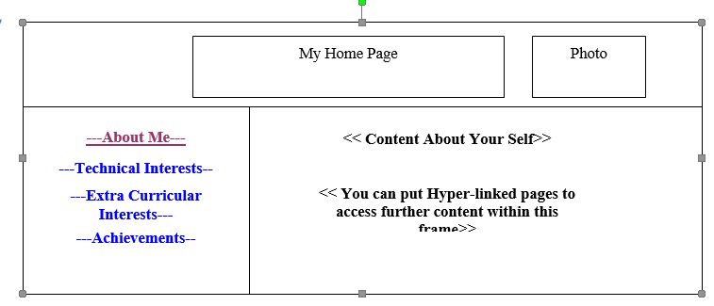

Design a Student Form using HTML5 which has following fields
  - Name : Required must be characters
  - Email : Validation placeholder: please enter valid email address
  - Phone : accept numbers in the following format (080-555-5555)
  - Semester : For the range 1 to 8
  - Branch :Data list
  - Website :Required pattern of the form-http://

Write the required HTML5 code to create an online user registration form which looks like the screenshot attached

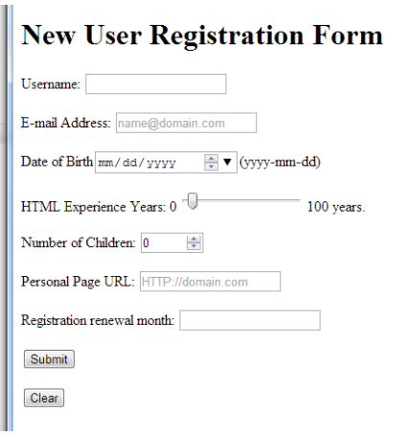

- Write the required HTML5 code to create an online feedback form for ISC students. The form should looks like the following screenshot.
